

hospital

Chained Like Prisoners

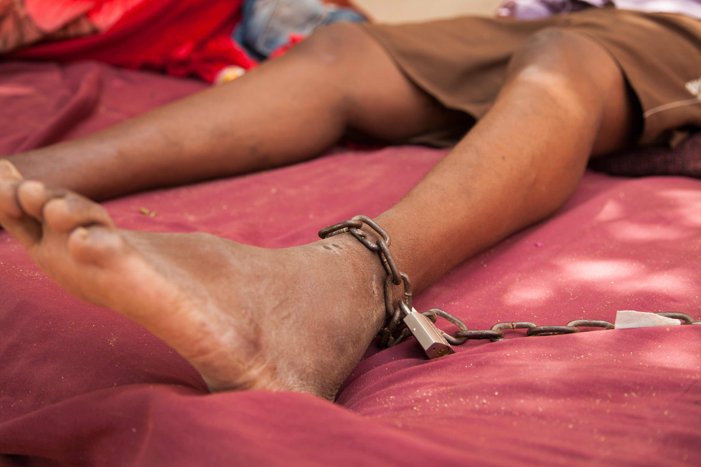
The abuse of people with a mental health condition in Somaliland
Who are we?

We are called Human Rights Watch.

We work to make sure everyone in the world is treated fairly and gets their rights.

What is this report about?

This report is about people with a mental health condition in Somaliland.



Somaliland is in Africa.

A mental health condition is about how a person thinks, feels or behaves.

For example, a mental health condition may make someone feel sad, worried or scared a lot.
In 2014 and 2015 we looked at what was happening in Somaliland.



We visited hospitals and other places where people with a mental health condition are taken to.

We talked to people with a mental health condition, hospital staff and others.


This report looks at:
- how people with a mental health condition are treated

- what we think should happen next

What is happening in Somaliland?


There are many people in Somaliland with a mental health condition.

This may be because of problems like:
- war
- a drug called khat that many people use
- not enough jobs or healthcare

People with a mental health condition in Somaliland are often treated very badly.

For example:

- they are often forced to stay in dirty places for a long time with too many other people

- they have no say about what happens to them. Their families decide what happens and when they leave
- they may be tied by the ankles with chains so they cannot move around

- people may hit them or shout at them

- people may force them to take medicine

- they cannot get the medical care, information or support they need in these places or when they leave

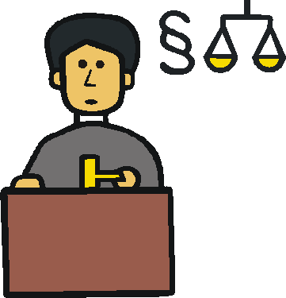

- there is no way for them to complain or change decisions.

There is no help from the law
- their families may be the only support they have.

But most families do not get the help they need to support a person with a mental health condition or help them make good decisions

- people often think bad things about people with a mental health condition

- there are not enough staff with good training or skills

There are more and more hospitals and other places where people with mental health conditions can be taken in Somaliland.


But there are no proper checks or rules to make sure these places are treating people well.

Many people told us they want to leave.

But they cannot because their families say no. Or they cannot find the right doctor to help them.

What should happen next

People should get the care and support they need in their local areas instead of being sent away to these places.

For now, Somaliland should:

- look at who is locked up in these places and let out people who do not want to be there

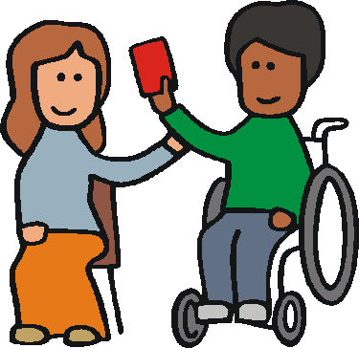

- make sure people can choose if they want to go to these places or not
Somaliland should also:

- make sure people are not hurt and treated badly in these places

- stop people being tied up with chains or locked in a room alone for a long time

- make sure people are not forced to take medicine unless it will save their life and it is the same medicine that people without disabilities would get

- do lots of checks to make sure these places are good and safe

After that, Somaliland should:

- make sure people can get good care and support in their local areas instead of these places

- make sure people can live safely in their local areas and are treated fairly

- tell more people in Somaliland about mental health and their rights

- make sure there are enough doctors and support staff with good training

Somaliland should make sure:

- people can get help if they choose to, like counselling and good medicine

- there are better laws and rules about how to treat people with a mental health condition fairly

- people with a mental health condition and their families have a big say in what happens

Abdi’s Story

Abdi is 35 years old.

He spent almost 2 years in a place for people with mental health conditions.

Abdi’s family sent him there because they thought he was sick and they did not know what to do.

Abdi was locked inside for most of the time.

He was tied by the ankles so he could not move easily.

Staff gave him medicine but did not ask him if it was OK or tell him what was happening.

He felt like he was in prison there.

He had to stay there until his family said it was OK to leave.

Now he lives with his sister.

He said he was very happy to leave.

Pictures The Picture Communication Symbols ©1981–2013 by DynaVox Mayer-Johnson LLC. All Rights Reserved Worldwide. Used with permission

